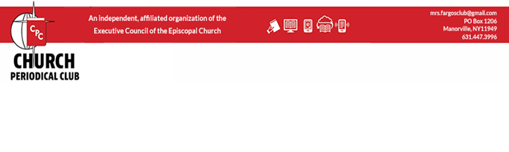

CPC – Church Periodical Club

Serving God's People Through the Written Word
The Church Periodical Club (CPC) is an Episcopal institution; its ministry is to make grants that supply written materials of any type free to those who cannot otherwise obtain them and to raise money to do this.
The Church Periodical Club is an independent, affiliated organization of the Executive Council of the Episcopal Church, dedicated to the worldwide Ministry of the Written Word and to the Promotion of Christian Mission. It is the only organization in the Episcopal Church dedicated solely to providing free literature and related materials, both religious and secular, through grants to people all over the world who need and request them and who have no other source for obtaining them. Prayer books, books for seminarians, educational materials, medical textbooks, agricultural manuals, and books for those in local and global mission are some of the publications The Church Periodical Club supplies.
Since its pioneer beginning, CPC has depended entirely on voluntary contributions to conduct its unique ministry. CPC is committed to supplying theological and educational materials in support of mission efforts around the world. CPC continues to respond to needs throughout the Anglican Communion. CPC is changing the world one book at a time.
Support the National Books Fund and Miles of Pennies through the Church Periodical Club in your parish, diocese, and province. As a Christian concerned with supporting missionary efforts, you are invited to give the gift that speaks volumes.

Louis Aloy
Province VIII CPC Representative

