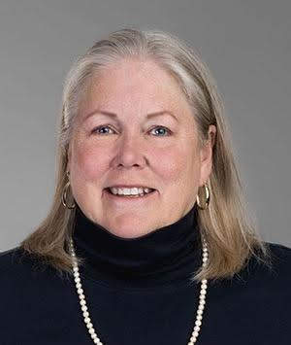
Cynthia Grua started string Anglican Prayer Beads in 2004 - when she found beads in the Episcopal Cathedral in Denver but could find nothing in Salt Lake City or online. She sends Full Circle Beads (FCB) beads to folks in all U.S. states and to dozens of countries from the U.K. and Australia to South Africa and South Korea. FCB rosaries are carried by a small number of cathedral shops including the Cathedral Bookstore/Atlanta and St. John the Divine/NYC.
Best of all, we connect with wonderful people who purchase FCB rosaries.

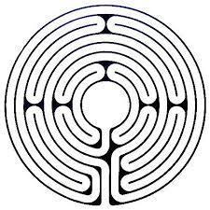
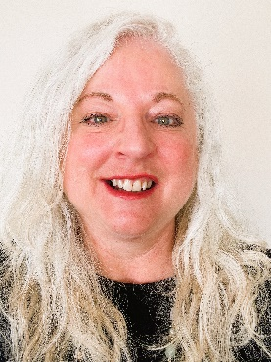
Laura Orcutt
A “cradle Episcopalian,” born, baptized, and confirmed in Jacksonville, FL., Laura Orcutt is a member of St James Episcopal Church in Utah. She has been involved with Episcopal Church Women (ECW) since she went to the ECW Triennial in 2009 in Los Angeles as a delegate. In 2015, the Diocese of Utah hosted General Convention and ECW Triennial in Salt Lake City, where she hosted and provided support for the ECW, UTO, and CPC boards in preparation and during their Triennials. She has also been a member of Church Periodical Club, where she has provided social media and technical support. She was the technical Zoom host for the CPC Triennial in 2021. She has planned and held ECW activities for her diocese and parish. Active in her diocese, she has hosted events this past year to include the virtual event Awakening to the Global Embrace of Beloved Community hosted almost literally around the world, held a Forum People Experiencing Homelessness in Utah with local key leaders who support people who are experiencing homelessness, and coordinated nine events in Utah for The Labyrinth Society’s World Labyrinth Day Walk as One at 1 for Peace. She volunteers at her parish Food Bank, serving almost 150 people each time they are open, volunteers and provides pastoral care at The Point, has given prayer at Interfaith events in SLC, and assists a remote Episcopal church in Alaska, which has a hybrid in-person and virtual presence. She is a Veriditas trained labyrinth facilitator, co-chair of the Diocesan Commission on Peace and Justice, a worship leader in her parish, mentor for Education for Ministry (EFM), and a grief facilitator. She is involved with Salt Lake Interfaith Roundtable and the Community of Hope International, who follows the rule of Benedict.

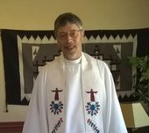
Michael Carney
Michael Carney, Native Midwesterners (from Iowa) married in 1982 and has a daughter and son, who've brought them three wonderful grandchildren. Spending time with the family is one of his greatest delights.

In the early years together, Michael worked as a preschool teacher. He was separated from organized religion for many years before returning to his roots in the Episcopal Church in 1991. Michael was ordained a priest. He served congregations in California and Colorado before coming to Utah in 2016.

Michael's gifts include children's ministry, pastoral care and leadership development. He enjoys preaching and helped create an innovative ministry program for youth based on community service. Mission trips broadened the relationships he already had with native people.

Michael is excited about serving at St. Elizabeth's in Whiterocks.
Art Empowers
Art Empowers (formerly Arts-Kids) ai an expressive arts program aimed at helping young people gain self-esteem, build community, express themselves through the arts, and learn healthy nutrition. They have lots of fun working with a variety of artistic media, playing games and socializing.
Experienced facilitators from the Ute Community help participants create safe spaces in which they can grow and develop. There is no charge for taking part, and young people ages 6-17 are encouraged to bring their friends.
We always have great fun, with art activities and games, and with transportation and meals provided.

