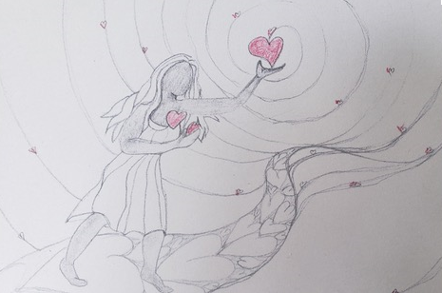
Leading With Heart

It is with joy that we continue to develop, learn and become through our time in Leading with Heart Circular Leadership. Working with women across the country, and predominately from our province, we explore, dream and become intentionally present to what we are tasked with. Originally we began work revisioning the former Women of Vision Leadership program and that has developed, been pruned and called into being a relevant viable model of leadership for Episcopal Church Women and women across the globe.
We look forward to presenting with the Green Tent in Chicago for the World Parliament of Religions in August, Non Violent Communication using the Circular Leadership model. Both Christine Budzowski and Evita Krislock were asked to serve on two different women’s leadership panels at the conference. Winnie Follett compliments our circles by being the third co convener of our workshop. We would like to offer a special thank you to the women who generously share their gifts with the circle, Barbara Schafer, Kay Lindahl, Rev. Rachel Tabor Hamilton, Christine Budzowski, Evita Krislock, Ann Smith, Lisa Towles, and Edna Brown. It is through them that this program continues to be birthed.

Respectfully,

Evita M Krislock

